## East West University

**Department of Computer Science and Engineering**

## A/2, Jahurul Islam Avenue, Jahurul Islam City, Aftabnagar, Dhaka

**Course Code:**

CSE405 (Networking Lab)

**Course Instructor:**

Rabea Khatun, Lecturer, CSE

Title: Configuration of FTP Server

## Objective(s)

* To learn about step-by-step configuration of FTP Server using Cisco Packet Tracer.
* To learn how to upload a file to the FTP Server.
* To learn how to rename and delete a file in an FTP server.
* To learn how to download a file from the FTP Server.

## Problem analysis

The File Transfer Protocol (FTP) is a standard network protocol used for the transfer of computer files between a client and server on a computer network. It uses a client-network architecture, which means that a user has to have an FTP client installed to access the FTP server running on a remote machine. After establishing the FTP connection, the user can download or upload files to and from the FTP server. To use FTP in Packet Tracer, its service must be enabled first. Then, a username, password, and permission (write, read, rename, delete, and list) have to be created. After connecting the server, FTP commands such as put, get, rename, dir, and delete can then be applied for the file operation. They will work based on the given permission to the username.

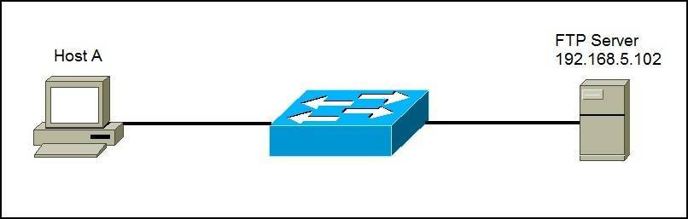

Figure 1: File Transfer

## Procedure

1. Create a network topology by setting up all the necessary devices in Cisco Packet Tracer.
2. Configure static **IP addresses** on the PC, Laptop, Server, and other devices.
3. For FTP Server Configuration, click on the Server and go to the FTP option then at the right side turn on the FTP server. After that, provide a username and password for the server. Then, provide the permission to access “Write”, “Read”, “Delete”, “Rename”, “List” options.
4. Now, an FTP client is built in the PC to send files to an FTP server configured in the Server. The FTP client can be used to read, write, delete and rename files present in the FTP server. For accessing the file, there are existing some commands which are listed below:
   1. **put** - used to upload a file to the server. For example: **put ABC.txt**
   2. **get** - used to get(download) a file from the server. For example: **get ABC.txt**
   3. **delete** - to delete a file in the FTP directory with the server. For example: **delete ABC.txt**
   4. **rename** – used to rename a file. Command: **rename “Old file name” “New file name”** . For example: **rename ABC.txt myFile.txt**
   5. **dir** – use to see the existing listed files in the FTP server directory
   6. **quit** – use to close the connection

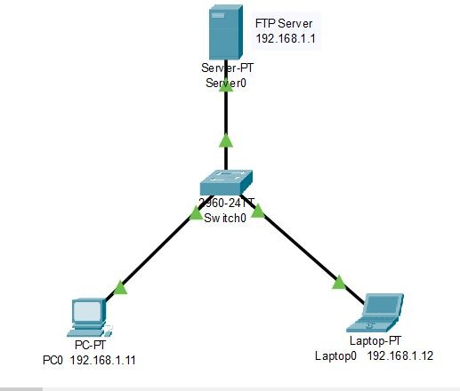

Figure 2: Build the network

## Configuration

1. Build the network topology (Figure 2).
2. Configure static **IP addresses** on the PC, Laptop, and FTP server (Figure 3).

a) Click the device and go to the **Desktop tab > IP Configuration**.

**For PC0:** Set 192.168.1.11 as IP address and 255.255.255.0 as Subnet Mask.

**For Laptop0:** Set 192.168.1.12 as IP address and 255.255.255.0 as Subnet Mask.

**For FTP Server:** Set 192.168.1.1 as IP address and 255.255.255.0 as Subnet Mask.

1. Click on the **Server** and then clicking on the **“Services”** option to FTP server configuration.
   1. Click on the **FTP** option then at the right side click **On** to enable the FTP server.
   2. Provide a **username** and **password** and then click on **“Write”, “Read”, “Delete”, “Rename”, “List”** options. At last, click the **“Add”** button (Figure 4).
   3. Now, an FTP client is built in the PC to send files to an FTP server configured in the Server. The FTP client can be used to read, write, delete and rename files present in the FTP server.

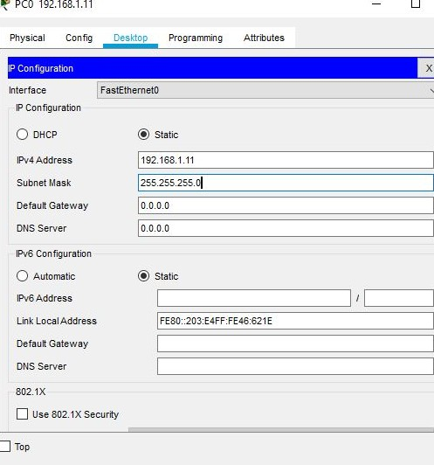 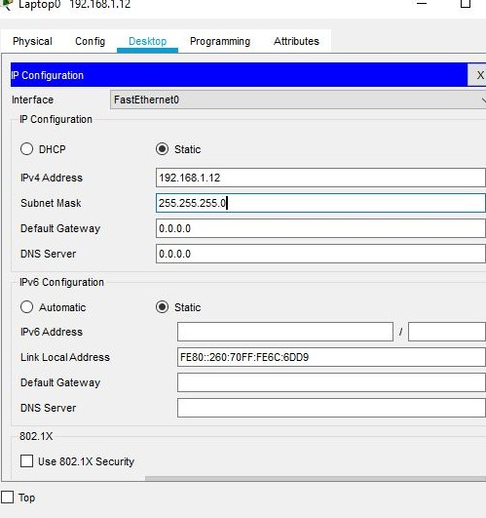

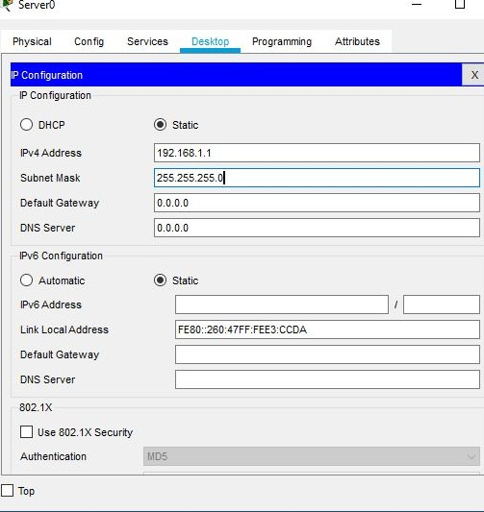(a) IP Configuration of PC0 (b) IP configuration of Laptop0

(c) IP Configuration of Server

Figure 3: IP Configuration of End Devices

## Input/Output

### Part 1: Login the FTP Server from PC’s Command Prompt

From the PC’s command prompt, the client access the FTP server using the server IP address. After typing the **ftp 192.168.1.1** command, press **“Enter”** . Then Provide the **username (admin)** and **password (admin)** for ftp login (Figure 5). PC0 has an FTP client which can be used to read, write, delete and rename files present in the FTP server.

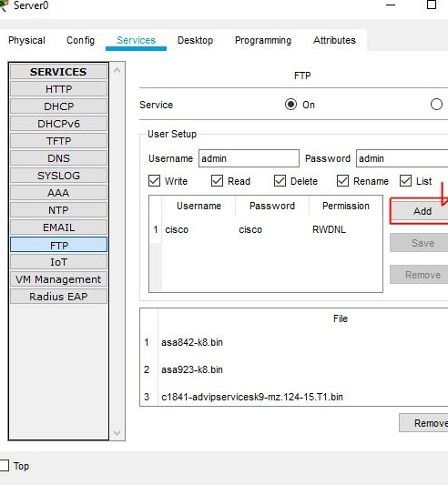 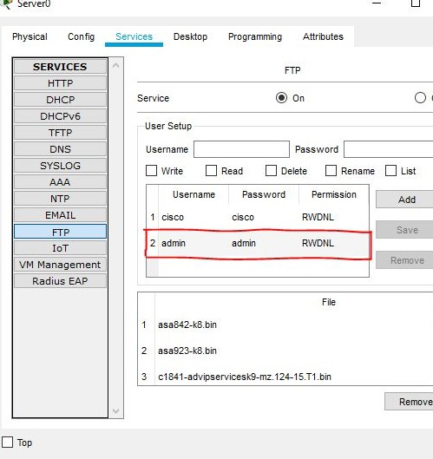

(a) (b)

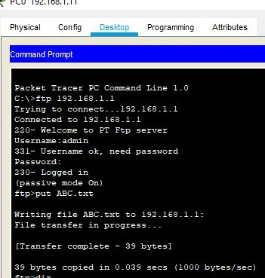Figure 4: Configuration of FTP Server

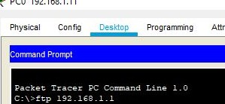

(a)

(b)

Figure 5: Login the FTP Server from PC’s Command Prompt

### Part 2: Upload a File to the FTP Server

1. Create a file in the PC then upload it to the server using FTP. To do this,
   1. Click **PC0** and click the **Desktop tab > Text Editor**.
   2. Create a file and give it your name of choice. Type any text in the editor then save your file. **e.g. ABC.txt**. Close the Text Editor when done (Figure 6).
2. Now upload the file from the PC0 to the server using FTP. In the Desktop tab, open the Command Prompt window and perform the following steps:

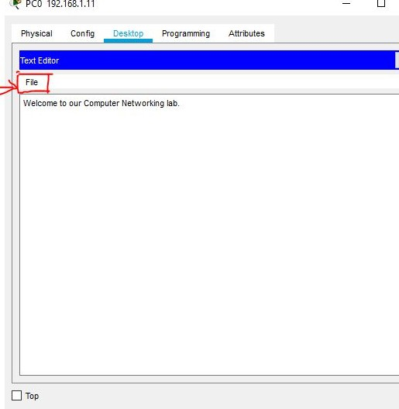 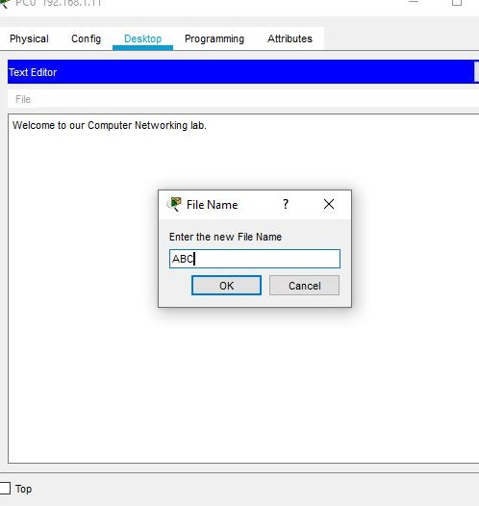

(a) Opening text editor from desktop (b) Renaming the newly created file

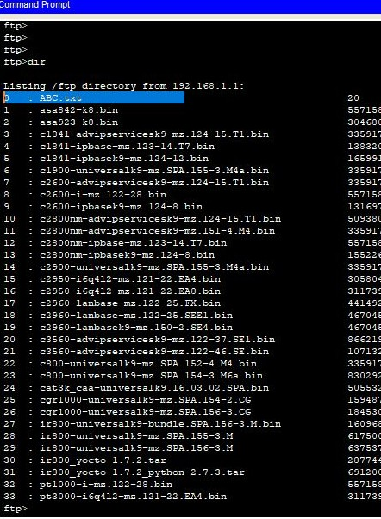Figure 6: Create a file

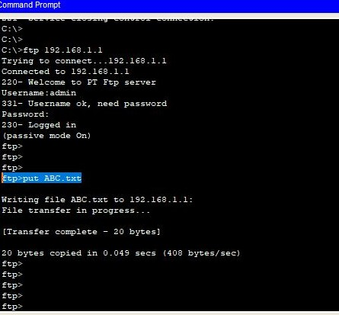

* 1. Upload a file
  2. Check the existing file

Figure 7: Uploading a file to the FTP server

(a) At the ftp> prompt, type **put ABC.txt**. The ABC.txt file is transferred from the PC0 to FTP Server.

1. After uploading the file to the server, verify the transfer of the file by typing **dir**. The ABC.txt file is now listed in the file directory (Figure 7).
2. Close the FTP client by typing quit.

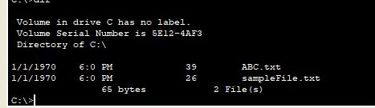

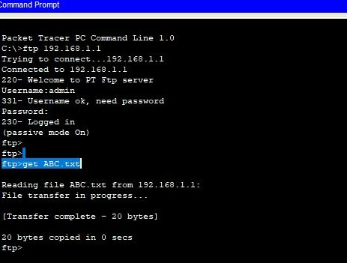(b)

(a)

Figure 8: Download a File from the FTP Server

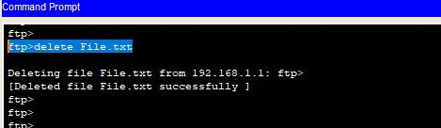

(b) Delete a file from the server

* 1. 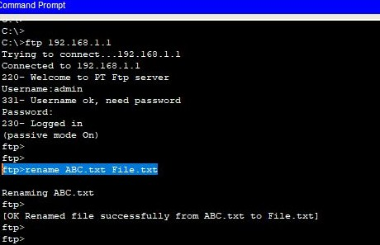Rename a file

Figure 9: Rename or delete any File from the FTP Server

### Part 3: Download a File from the FTP Server

1. Suppose, a client wants to download the file from FTP server. First, click Laptop0 and click the **Desktop tab > Command Prompt**.
   1. Type **ftp 192.168.1.1**
   2. Provide the **username (admin)** and **password (admin)** for ftp login.
   3. **Download** the ABC.txt file: at the ftp> prompt, type **get ABC.txt**. The ABC.txt file is transferred to Laptop0.
   4. Close the FTP client by typing quit.
2. Verify the transfer of the file to Laptop0 by typing dir. ABC.txt is listed in the directory (Figure 8).
3. Close the command line window

### Part 4: Rename or delete any File from the FTP Server

1. Suppose, a PC0 wants to rename or delete a file from FTP server. First, click **PC0** and click the **Desktop tab > Command Prompt**.
   1. Type ftp 192.168.1.1
   2. Provide the username (admin) "and password (admin) for ftp login.
   3. **Rename the ABC.txt file:** at the ftp> prompt, type **rename ABC.txt File.txt**.
   4. Verify the file to PC0 by typing dir. File.txt is listed in the directory.
   5. **Delete the File.txt file from FTP Server:** at the ftp> prompt, type **delete File.txt**.

## Discussion & Conclusion

Based on the focused objective(s) to learn the step-by-step configuration of FTP server. This task will help us to learn how to use the FTP services to transfer files between clients and the server. The additional lab exercise on FTP server will help us to be confident towards the fulfilment of the objectives(s).

## Lab Task (Please implement yourself and show the output to the instructor)

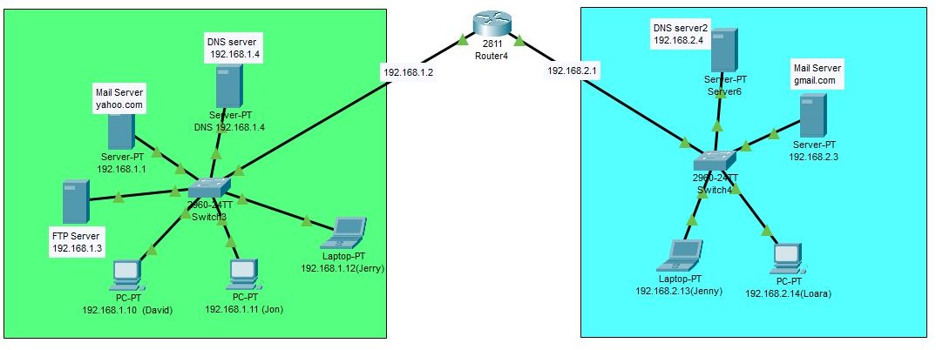In the previous task, the files are transferred to the same network. In this task, the file transfers the client to the server from two different networks. A switch connects the devices of Mirpur branch and similarly the devices of Uttara branch. A router connects all the devices of these two branches. Here, need to design the network and configure the devices according to the given information. Then, transfer of computer files between a client and server on the netwo